How to View Open CARs in NS5
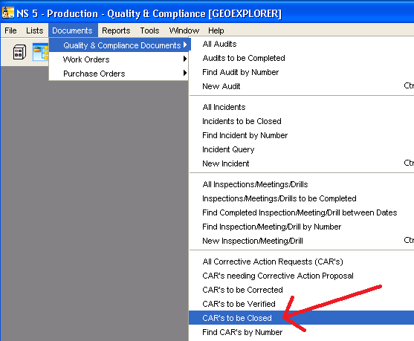
To Print a List of Open CARs
Click the right arrow button to print any list in NS5 or or export it to an excel file.
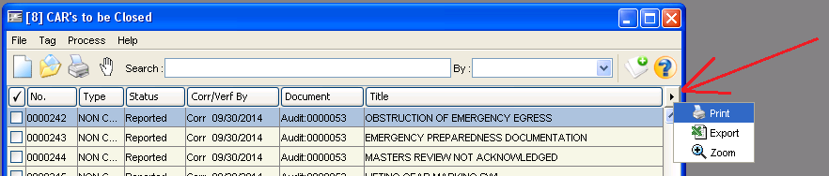
To Print or Save Report as a pdf
